Fixguru Round 3 Tech Brief

Fixguru Round 3 — Tech Brief
Session: MAIA <> Fixguru UAT (Onsite), 24 June 2026
Attendees (Mindhive): Ivan, Gareth, Jermaine, Azib, Brendan, Bryan, Johnson
Attendees (Fixguru): Ivan Cyh (Marcus), Yvonne (referenced), Azib
Pass gate: user completes end-to-end order without opening AutoCount or asking for price manually.

Overall Pass Gate — Round 3 Sign-off
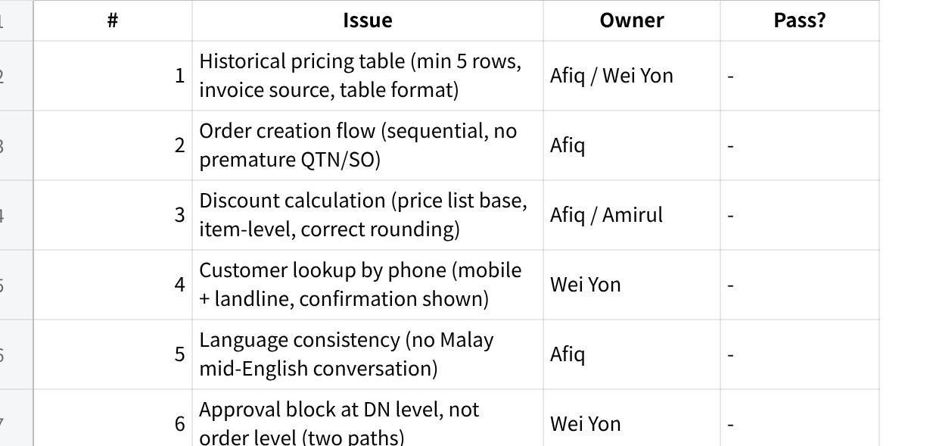
点击图片可查看完整电子表格
Sign-off authority: Gareth (pending confirmation — Open Decision C6 in backward plan)

Issue 1 — Historical Pricing Display P0 RECURRING
Feedback (Fixguru UAT, 24 Jun — same feedback since 7 Apr, 14 May, 16 Jun)
"Sales team needs historical pricing per customer per item before proceeding with any order. Current chatbot only shows one transaction line — incomplete and misleading. Need at least 5 historical transactions per item with date. Clean table — one glance. Grand total not needed at this stage."
Yvonne's walkthrough: user specifies G3-100, G1-300, PM72-500 → if any historical pricing, surface based on invoiced amount → chatbot returns table per item → ask user which price to proceed with.
"Search older invoices. People who use MAIA are very simple minded. If head of departments need 5 minutes to digest, their team will take much longer. MAIA must be super direct." — Ivan's raw notes
Gaps — Product
- No table format spec written (columns, row count, sort order)
- No hard rule for min row count (client said 3 is too few — never formalised)
- Grand total suppression never written into spec
- Date column never included in any spec — client explicitly requires it
- Source rule (invoice vs draft SO) never documented — assumed same
Gaps — Tech
- API returning only 1 transaction per item
- No date field in response
- Source mixing draft SOs with confirmed invoices
- Discount % calculated against wrong base
- Still returning inline text, not table structure
Acceptance Criteria (AC-01)
Scenario: Sales user pastes WhatsApp order from returning customer (3 items).
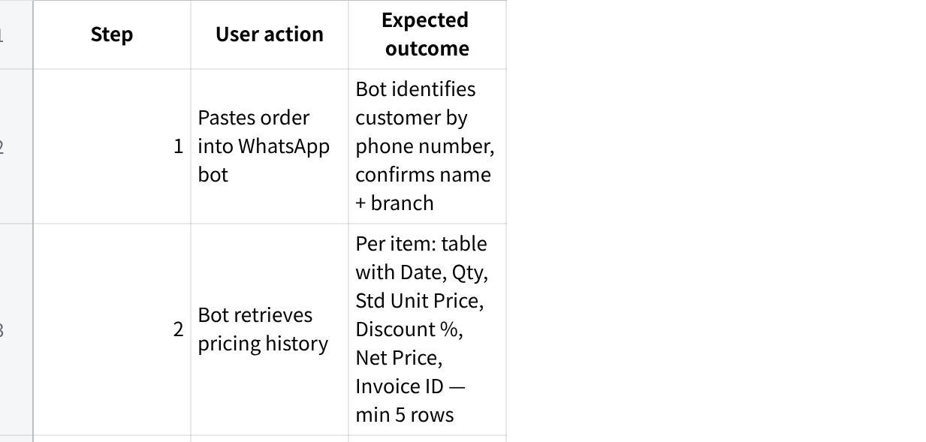
点击图片可查看完整电子表格
Pass:
- Min 5 invoice-sourced rows per item (never draft SOs)
- Table visible in single message — no text wall
- Bot does NOT auto-generate QTN/SO before user confirms price
- Date column present
Fail (from prior UAT): only 2–3 rows; draft SO source; QTN generated before discount picked.
Action — Product
- Write table spec: columns = Date | Item Code | Qty | Std Unit Price | Discount % | Net Price | Invoice ID
- Hard rule: min 5 rows (3 is explicitly too few); sort most recent first
- Source rule: confirmed invoices only — never draft SOs
- Remove grand total from chatbot response; total visible in PDF only
Action — Tech
- Rebuild historical pricing API: return all 6 columns per row; min 5 rows; filter confirmed invoices only (Afiq / Wei Yon)
- If fewer than 5 invoices exist, return all available + note count
- Output as structured table, not inline text

Issue 2 — Order Creation Flow Sequence P0
Feedback (Fixguru UAT, 24 Jun)
"Confirm to proceed with quotation, yes, that's all. User wants a super simple flow. One step at a time — no multi-question prompts."
Ideal flow: (1) identify customer by phone → (2) retrieve historical pricing table → (3) "Proceed with these prices?" yes/no → (4) generate QTN/SO → (5) ask delivery method.
"Expect from user, only yes and no questions." — Ivan's raw notes
Gaps — Product
- No happy-path flow spec written step-by-step with exact bot messages
- No rule that QTN/SO must not generate before price confirmation
- No defined fallback for partial item confirmation
Gaps — Tech
- Bot generating QTN/SO before user confirms price
- Bot asking multiple questions in same message
- No state enforcement for sequential steps
Acceptance Criteria (AC-01 Step 4–5 / flow gate)
Pass:
- Bot sends one question per message — never multiple at once
- QTN/SO only generated after explicit "yes" from user on price
- Flow is resumable if user skips a step (bot re-prompts, not crash)
Action — Product
- Write step-by-step happy-path spec: each step = one bot message + one expected user response + transition condition
- Define exact wording for each prompt
- Define fallback: if user skips step, what bot does next
Action — Tech
- Gate QTN/SO generation on explicit user price confirmation (Afiq)
- Implement strict sequential step model — each step blocks next until resolved
- Add conversation state tracking so user can resume mid-flow

Issue 3 — Discount Calculation Accuracy P0
Feedback (UAT prep 16 Jun + UAT 24 Jun)
"Price list rate and SSC found to be different during testing — discount must use price list rate (standard selling price), not the item price. Unique price discount vs. total line item discount are separate values; both must be shown correctly."
Session: discount % varies by customer and quantity — not standardised globally. Some customers have pre-agreed prices below standard minimum.
Gaps — Product
- No documented rule: which price is the base for discount % (price list vs SSC vs item price)
- Pre-approved customer-item price concept never specced
- No rule: do pre-approved prices bypass the minimum price approval trigger?
Gaps — Tech
- Discount using item price not price list rate (price list vs SSC bug flagged 16 Jun — unresolved)
- Showing unit discount only; not showing total line discount
- No pre-approved customer-item price bypass in approval check
Acceptance Criteria (AC-02)
Scenario: User selects 5% discount for item G1 (std price RM 0.33).
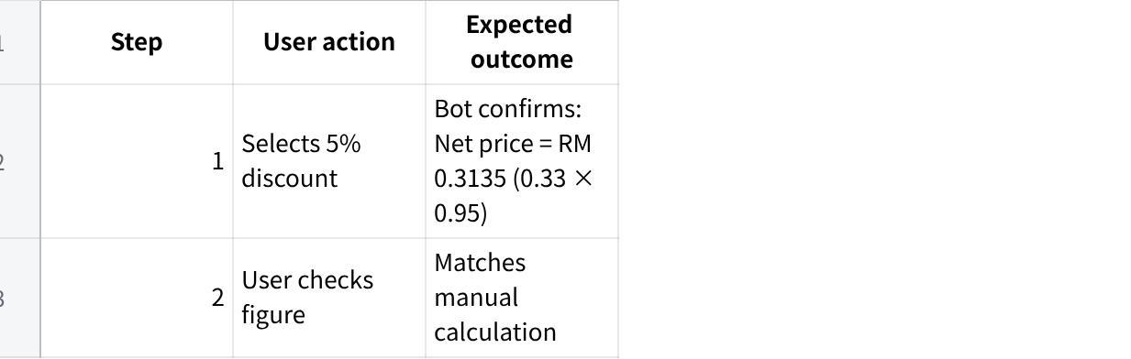
点击图片可查看完整电子表格
Pass:
- 3% / 5% / 10% all compute correctly against price list rate (not item price)
- Different items in same order can carry different discount %
- Net price shown rounds to 4 decimal places (or client-agreed standard)
- Total line discount shown alongside unit discount
Action — Product
- Define rule: discount % = (price list rate − net price) / price list rate
- Define pre-approved customer-item pricing: customer + item + agreed net price → no approval triggered
- Spec: show unit discount AND total line discount on order
Action — Tech
- Fix discount base: use price list rate not item price; resolve price list vs SSC discrepancy (Amirul / Afiq)
- Show both unit discount and total line discount in response
- Implement pre-approved customer-item price bypass in approval check

Issue 4 — Customer Lookup by Phone Number P1
Feedback (Fixguru UAT, 24 Jun)
"Leads and prospects — always know either phone number or WhatsApp, but sometimes don't even know their name. Mobile field in AutoCount is a unique identifier for most customers."
"Customer retrieval and referencing by phone number. mobile/landline." — Ivan's raw notes
Gaps — Product
- No customer search priority spec (phone → landline → name)
- No spec for multiple-match scenario
- No lead/prospect creation flow if no match found
- No confirmation step spec before order created
Gaps — Tech
- Search only using name or one phone field; not covering both mobile and landline
- Silent auto-match risk — no confirmation shown before proceeding
- Branch/contact not synced: SO/DN defaults to HQ instead of matched branch
Acceptance Criteria (AC-03)
Scenario: Customer WhatsApps in with no company name — only phone number.
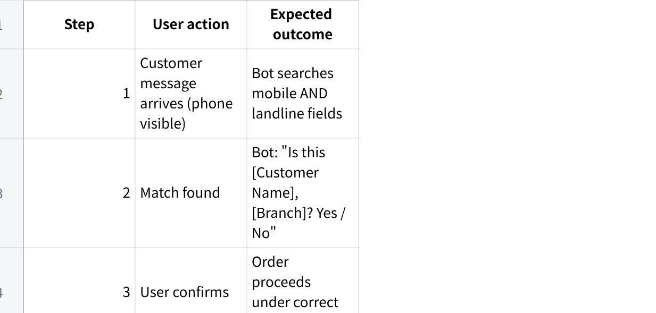
点击图片可查看完整电子表格
Pass:
- Phone search covers both mobile and landline fields
- Confirmation step shown before proceeding — no silent auto-match
- SO/DN branch/contact = matched branch, not HQ default
Action — Product
- Define search priority: phone/mobile → landline → name
- Define lead/prospect creation: if no match, offer "Create as lead?" requiring phone only
- Define confirmation prompt wording
Action — Tech
- Search both phone and mobile columns in AutoCount (Wei Yon)
- Show confirmation before proceeding
- Sync branch/contact to SO/DN from matched customer, not HQ default

Issue 5 — Language Bug (Malay Mid-Conversation) P0
Feedback (Ivan's raw notes, 24 Jun)
"Chatbot quick replies use Malay suddenly when majority of the chat is in English. To check." — Afiq flagged
Gaps — Product
- No language consistency rule in any spec
- No definition of how bot determines session language
Gaps — Tech
- Quick reply label generation not respecting conversation language
- Language detection not propagated to quick reply builder
Acceptance Criteria (AC-04)
Scenario: Sales user conducts entire conversation in English.
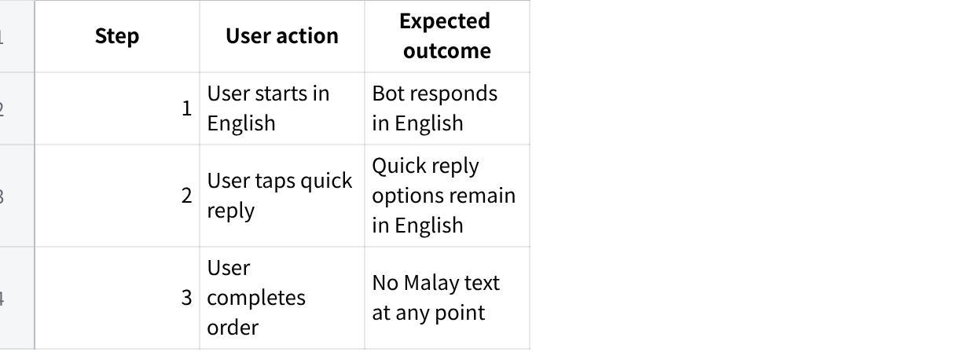
点击图片可查看完整电子表格
Pass:
- Zero mid-flow Malay switch in English conversation
- Quick reply labels in English throughout
Action — Product
- Define rule: quick reply labels must match conversation language throughout session
- Define detection: first user message language = session language
Action — Tech
- Fix quick reply generation: pass session language to reply builder; no Malay fallback (Afiq)
- End-to-end test: English order → verify all quick replies in English

Issue 6 — Approval Blocks: Credit Limit and Minimum Price P1
Feedback (Fixguru UAT, 24 Jun)
"Credit limit block on order — miss opportunity to collect money and invoice. Fix guru side: credit limit block on DN. If customer high outstanding, will block on DN. Based on DO value, will block."
"Sales order minimum discount by item: minimum price needs approval. Which roles can bypass? Check with Azib screenshot on AutoCount."
"Team approves manually after verifying bank transfer slip even if AR not yet knocked off."
Gaps — Product
- Block level not locked in writing — client leans DN but no formal confirmation
- Which roles can bypass: unknown — waiting on Azib's AutoCount screenshot (C2 blocker)
- Two distinct approval paths not defined: AR-negative ≠ credit-limit-exceeded
- Pre-approved customer-item prices still triggering minimum price approval incorrectly
Gaps — Tech
- Block triggering at SO level, not DN/DO level
- Approval flow not split: AR-negative and credit-limit-exceeded treated as one flow
- No approver visibility: AR, pending SO/DN, credit limit, available balance
- Pre-approved prices not bypassing minimum price check
Acceptance Criteria (AC-05)
Scenario: Item priced below minimum floor. User mid-order.
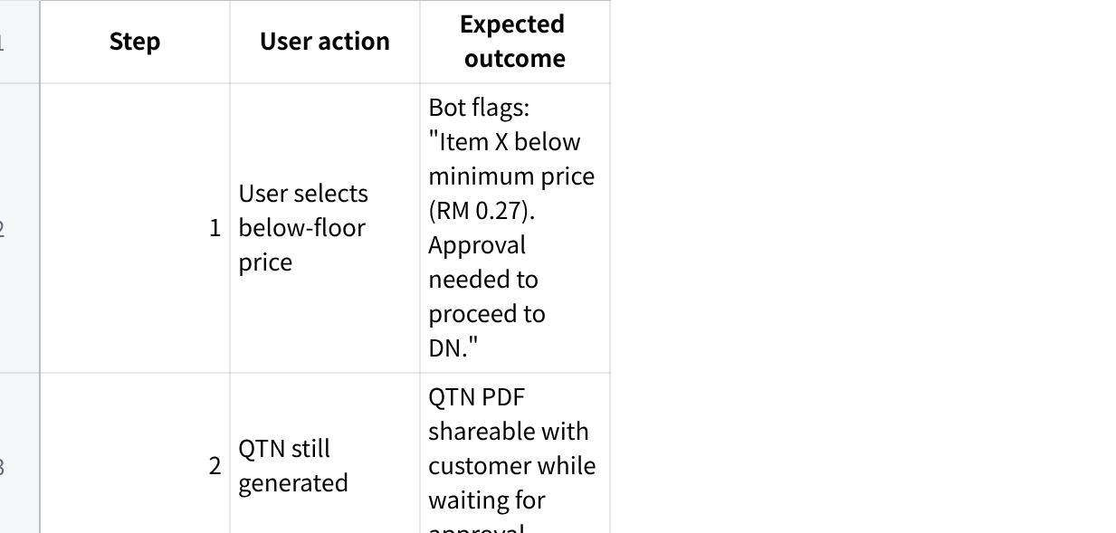
点击图片可查看完整电子表格
Pass:
- Order creation NOT blocked — only DN submit blocked
- QTN still generated and shareable pending approval
- Approver sees: AR, pending SO/DN value, credit limit, available balance
- Two flows separated: AR-negative (bank-in slip) vs credit-limit-exceeded (case-by-case)
Action — Product
- Lock block level in writing: DN submit only (pending client formal confirmation)
- Chase Azib for AutoCount screenshot of both blocks + bypass roles (C2 — Ivan to action)
- Write two distinct approval flows: (A) AR-negative → bank-in slip; (B) credit-limit-exceeded → case-by-case
- Define approver view: AR, pending SO/DN, credit limit, available balance
Action — Tech
- Move credit block trigger from SO to DN submit; use DO value as trigger (Wei Yon)
- Separate approval routing: AR-negative path vs credit-limit path → both route to Ivan
- Build approver context: AR, pending SO/DN, credit limit, available balance
- Implement pre-approved customer-item price bypass in minimum price check

Issue 7 — Delivery Method as Item Line P1
Feedback (Fixguru UAT, 24 Jun)
"Historical shipment method, surface the column from sales order listing. In the user context this must be captured. Customer context bank should have historical N (minimum 5) confirmed documents."
"Is this lalamove order, self pickup?" — Marcus's feedback (chatbot must prompt this)
Gaps — Product
- No spec for delivery method as SKU/item line (currently free-text or config)
- No spec for surfacing last 5 delivery methods per customer
- No delivery address history spec (separate from method — see Issue 9)
Gaps — Tech
- Delivery charge not appearing as item line with item code
- No historical delivery method retrieval from SO history
- Delivery accounting treatment not mapped per method type
Acceptance Criteria (AC-06)
Scenario: User selects "Lalamove" as delivery method after QTN confirmed.
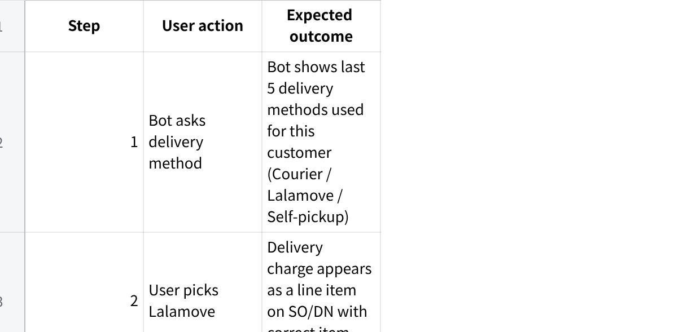
点击图片可查看完整电子表格
Pass:
- Last 5 confirmed delivery methods surfaced per customer
- Delivery charge = item line, not free-text field
- Correct item code maps to correct accounting treatment
Action — Product
- Define delivery method as SKU: each method has item code, description, charge rule
- Spec: surface last 5 confirmed delivery methods from SO history per customer
- Align with Fixguru on delivery charge amounts per method (own lorry vs Lalamove vs self-pickup)
Action — Tech
- Delivery charge as item line on SO/DN with correct item code (Wei Yon)
- Historical delivery method retrieval: last 5 confirmed SOs per customer (Wei Yon)

Issue 8 — Chatbot Verbosity P0
Feedback (Fixguru UAT, 24 Jun)
"Responses are too long, too many numbers, hard to scan in one glance. Sales staff will revert to AutoCount if Maya is slower or more confusing. Key principle: Maya adapts to the user, not the other way around."
"Be concise in the response, if not found then not found, don't need to over enrich." — Ivan's raw notes
Gaps — Product
- No response length spec or max-message rule
- No single-action-per-message rule
- "Not found = not found" principle never formalised
Gaps — Tech
- Bot returning multi-paragraph responses for single queries
- No character/line limit enforced on output
- Over-enrichment on "item not found" path
Action — Product
- Define chatbot response spec: max 3 lines per message, one action per turn
- Write "not found" rule: return exactly one line — "No record found for [item]. Proceed with standard price?"
Action — Tech
- Rewrite chatbot prompts: enforce single-step, single-question output (Afiq)
- Remove all enrichment beyond what was asked
- Enforce output character constraint before forcing new turn

Issue 9 — WhatsApp Latency vs Telegram P1
Feedback (Ivan's raw notes, 24 Jun)
"Observation from chatbot in WhatsApp: the latency is a bit longer vs Telegram."
Gaps — Product
- No latency SLA defined
Gaps — Tech
- Root cause of WhatsApp vs Telegram latency gap unknown; no profiling done
Action — Product
- Define latency SLA: target <5 seconds from user send to bot reply
Action — Tech
- Profile WhatsApp API call chain vs Telegram — identify bottleneck (Wei Yon)
- Report findings before next UAT

Issue 10 — AutoCount External ID Not Returned P1
Feedback (UAT prep, 16 Jun)
"External ID from AutoCount must be returned on SO/invoice after push. Currently returning internal ID in some cases. On submit: push to AutoCount first, then return external ID."
Gaps — Product
- No spec: which ID to show user after submit
Gaps — Tech
- Returning MAIA internal ID in some cases instead of AutoCount external document ID
- External ID not mapped back after AutoCount push
Action — Product
- Spec: after submit, display AutoCount external document ID — not MAIA internal ID
Action — Tech
- Fix push flow: push to AutoCount → receive external ID → return it in response (Bryan)
- Store external ID on MAIA SO/invoice record

Issue 11 — Custom Item Naming + Item Retrieval Fallback P1
Feedback (Ivan's raw notes, 24 Jun)
"Fixguru has G5 as a base item, but they create customised G5: {Customer Name} G5. Item retrieval — if not match, also return historical items that the customer ordered."
Gaps — Product
- No spec for {Customer Name} prefix variant lookup or resolution to base item
- No defined fallback when item not found
Gaps — Tech
- Item search not handling customer-variant naming
- Dead-end returned when item not found — no fallback
Action — Product
- Define retrieval priority: exact match → strip prefix → base item → customer invoice history
- Define fallback message: "No match for [item]. Closest: [base]. Historically ordered: [list]"
Action — Tech
- Implement 3-tier lookup: exact → prefix-stripped base → customer history (Wei Yon / Afiq)
- Never return a dead-end; always provide at least historical fallback

Issue 12 — FOC Items and Partial Fulfillment P1
Feedback (Fixguru UAT, 24 Jun)
"FOC items: customer ordered 1000, production 1050 → 50 are free. Partial fulfillment: if stock short, issue DO for available stock, backorder remainder. Maya should support adjusting SO quantity and issuing DO directly."
Gaps — Product
- FOC flow never specced: billing logic, stock deduction, DO line appearance
- Partial fulfillment flow not defined
Gaps — Tech
- FOC items creating duplicate lines (flagged in UAT prep 16 Jun)
- Partial DO not supported — system requires full quantity
- No natural-language SO quantity adjustment in bot
Action — Product
- Write FOC spec: bill billable qty; deduct billable + FOC from stock; FOC line on DO at RM 0
- Write partial fulfillment spec: adjust SO qty + issue partial DO + backlog remainder
Action — Tech
- Consolidate FOC lines: deduplicate into single line per item (Bryan)
- Support partial DO against SO; track backorder remainder (Wei Yon)
- Support natural-language SO qty adjustment in bot flow

Issue 13 — Warehouse / Shelf Configuration P1
Feedback (Fixguru UAT, 24 Jun)
"Current AutoCount setup ties shelf to item UOM, not to sub-warehouse. Industry standard: shelf as sub-warehouse within rack within HQ warehouse. Need to investigate correct AutoCount module."
Gaps — Product
- Warehouse structure never mapped from Fixguru's actual AutoCount setup
- AutoCount sub-warehouse capability not validated
Gaps — Tech
- Wrong module used for shelf tracking (tied to item UOM)
- Picking list / DN not showing correct shelf/warehouse
Action — Product
- Map intended hierarchy with Fixguru: HQ → rack → shelf
- Validate with AutoCount vendor if sub-warehouse module supports this
Action — Tech
- Investigate correct AutoCount sub-warehouse module (Azib / Wei Yon)
- Reconfigure shelves as sub-warehouses; update picking list and DN

Issue 14 — Dual Interface / Hybrid UX Open Decision
Feedback (Fixguru UAT, 24 Jun)
"MAIA's perhaps a dual interface — chat + front. The chat interface has its limitations. Sales people have to do manual data entry but rely on rich information best surfaced in the front end."
"Marcus's feedback: chatbot intuitive, user-guided flow. Dual interface concept positively received."
Gaps — Product
- No decision made: chat-only vs dual interface vs image/table card
- Without this decision, pricing table display spec cannot be finalised
Gaps — Tech
- No feasibility spike on hybrid chat + web panel
- No design spec to build towards
Action — Product
- Make explicit decision by Day 1 (25 Jun): chat-only / dual interface / image card — must lock before table spec finalised
- If dual interface: define scope — Phase 1 or costed CR
Action — Tech
- Feasibility spike: hybrid web panel alongside WhatsApp chat — timeboxed 1 day (Jermaine / Amirul)
- Run in parallel with P0 fixes — must not block Issue 1 delivery

Source Notes
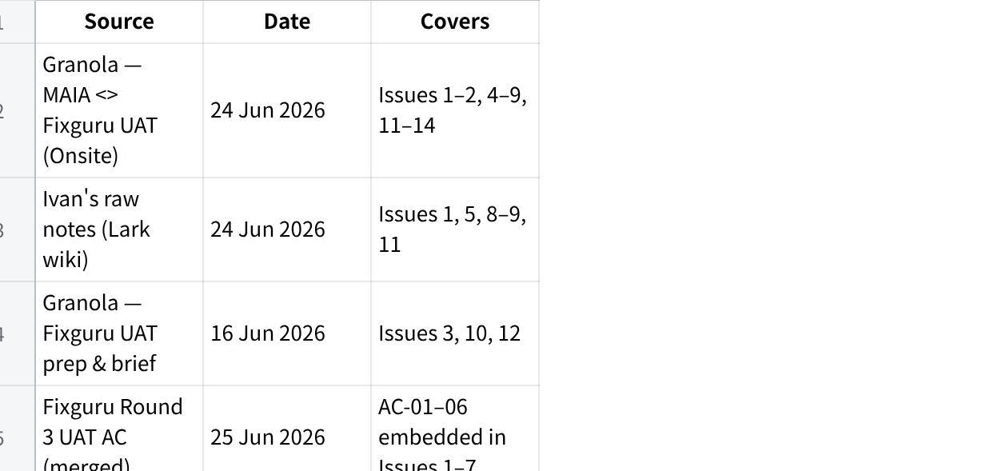
点击图片可查看完整电子表格

See Also
- UAT/3rd backward final UAT action plan for Fixguru — prioritised plan with owners and dates
- Meetings/2026-06-24 Fixguru UAT Debrief — Ivan's raw session notes
- context/learnings — running learnings log

